Peer Instruction: A Teaching Method to Improve Conceptual Understanding

Development of research-based teaching methodology which teachers use to evaluate student comprehension, provide ongoing feedback to improve their learning gains is important at all levels of physics instruction. Peer Instruction is one such interactive teaching methodology used for formative assessment. Peer instruction was introduced by Prof. Eric Mazur from Harvard University in the 1990s for the introductory physics courses. As stated by Eric Mazur “the fundamental role of implementing peer instruction in class is to exploit student interaction during lectures and focus student’s attention on underlying concepts”.
In the Peer Instruction approach, after a brief presentation by the instructor several multiple choice questions known as concept tests are asked during the class. The concept tests is a conceptual question based on a core concept that is being covered in the course and is usually targeted to address student’s misconceptions. First, the students think individually and are given 2-3 minutes to answer the concept question. After they report their answer, students work in a small group of three or four to discuss their individual answers to the question and to arrive at consensus on the correct answer. In order to reach consensus, students must explain their own reasoning and problem solving in support of their answer. After the group discussion, students are then asked to individually answer the question a second time. The entire class participates in discussion led by student explanations of their group’s findings before the instructor answers the question.

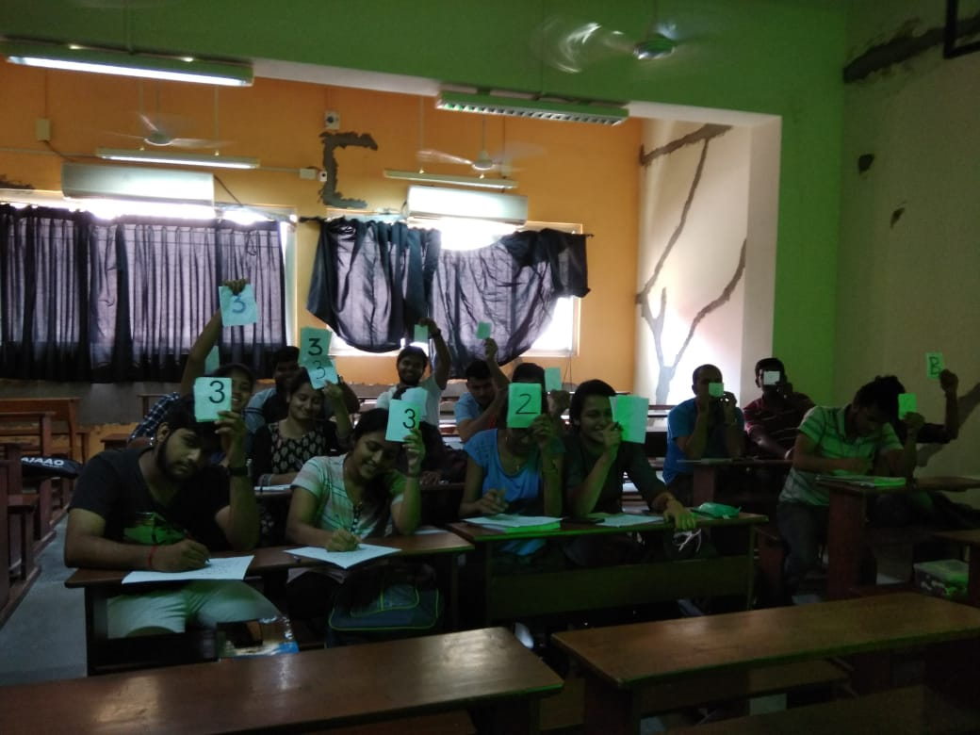
Second Year B.Sc. Physics students during the lecture of Quantum Mechanics.

